Lab 7-1 Creating an SDE Mapping for a Fact Table
Goals | To create a fact table Source Dependent Extract (SDE) mapping that can be used to extract and move data from a source table into a Siebel Relationship Management Warehouse staging table in preparation for load into a target table.
Scenario | You have identified the Siebel Relationship Management Warehouse tables where you are going to extract and load data and now must create mappings to coordinate the ETL process. You must first create a Source Dependent Extract mapping.
Outcome | You will have a Source Dependent Extract mapping that extracts data from the S_REVN, WC_PERSON_D, and WC_PROD_D tables and loads it into corresponding columns in the WC_RVF_FS staging table in the Siebel Relationship Management Warehouse.
Time | 30 – 40 minutes
Environment | 
Instructions:
- If necessary, start the Informatica Designer tool and connect to the Siebel Informatica repository.
  - Select Start > Programs > Informatica PowerMart 6.2.1 OEM for Siebel > Designer.
  - Double-click Siebel_DW_Rep.
  - In the Connect to Repository dialog box, enter the following:
Username | Administrator
Password | Administrator
  - Click Connect.
- Import the ETL_LAB_OLTP source you will use to create a Source Dependent Extract (SDE) mapping.
  - Select the Custom folder and select Tools > Source Analyzer. Verify that the Designer toolbar displays Custom in the drop-down field in the upper-left corner.
  - Select Sources > Import from Database. The Import Tables dialog box appears.
  - Click the browse button (…) next to the ODBC data source field to open the ODBC Data Source Administrator.
  - Click the System DSN tab.
  - Click Add.
  - In the Create New Data Source dialog box, select SQL Server and click Finish.
  - The Create a New Data Source to SQL Server wizard appears.
    - Enter the following values:
Name | ETL_LAB_OLTP
Server | <machine name>
    - Click Next.
    - Select With SQL Server authentication using a login ID and password entered by the user and enter the following values:
Login ID: | SIEBEL
Password: | SIEBEL
    - Click Next.
    - Select Change the default database to: and select ETL_LAB_OLTP from the drop-down list.
    - Click Next.
    - Click Finish.
  - In the ODBC Microsoft SQL Server Setup dialog box, click Test Data Source to test the connection. When the test completes successfully, click OK.
  - Click OK to return to the ODBC Data Source Administrator.
  - Click OK to close the ODBC Data Source Administrator and return to the Import Tables dialog box.
  - Select ETL_LAB_OLTP (SQL Server) from the ODBC data source drop-down list.
  - Enter the following:
Username: | SIEBEL
Owner name: | SIEBEL
Password: | SIEBEL
  - Click Connect.
  - Under Show owners, click All.
  - Expand dbo and the TABLES sub-folder.
  - Select the S_REVN table.
  - Click OK.
  - In the Navigator, select Custom > Sources and verify that the ETL_LAB_OLTP source appears and contains the S_REVN table.
  - Change the database type of S_REVN source object to Oracle. Even though the database used in the lab is Microsoft SQL Server, it is recommended that database type is set to Oracle for Source and Target objects for consistency and interoperability across different database vendors. This allows Informatica repository developed in one database platform to be easily ported over to another database platform. In order to maintain this consistency and to provide seamless integration with as-delivered source and target objects, you will need to change the database type for custom imported source and target objects.
    - Double-click S_REVN object.
    - Click the Table tab.
    - Click the Database type drop-down list box and change the database type from Microsoft SQL Server to Oracle.
    - Click Apply.
    - Click OK.
  - Select Repository > Save.
  - In the Output window, verify that the S_REVN source was inserted.
  - S_REVN table definition:
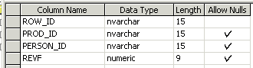
  - Preview S_REVN data:
    - Select S_REVN table.
    - Right-click the S_REVN table.
    - Select Preview Data.
    - Enter the following:
Username: | SIEBEL
Owner name: | dbo (Pre-selected)
Password: | SIEBEL
    - Click Connect
    - Preview the S_REVN data
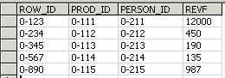
    - Click Close to close the Preview Data window.
- Import the ETL_LAB_DW source you will use to create a Source Dependent Extract (SDE) mapping.
  - If necessary, click the Custom folder and select Tools > Source Analyzer.
  - Select Sources > Import from Database. The Import Tables dialog window appears.
  - Click the browse button next to the ODBC data source field to open the ODBC Administrator.
  - Click the System DSN tab.
  - Click Add.
  - In the Create New Data Source dialog box, select SQL Server and click Finish.
  - The Create a New Data Source to SQL Server wizard appears.
    - Enter the following values:
Name | ETL_LAB_DW
Server | <machine name>
    - Click Next.
    - Select With SQL Server authentication using a login ID and password entered by the user and enter the following values:
Login ID: | SIEBEL
Password: | SIEBEL
    - Click Next.
    - Select Change the default database to: and select ETL_LAB_DW from the drop-down list.
    - Click Next.
    - Click Finish.
  - In the ODBC Microsoft SQL Server Setup dialog box, click Test Data Source to test the connection. When the test completes successfully, click OK.
  - Click OK to return to the ODBC Data Source Administrator.
  - Click OK to close the ODBC Data Source Administrator and return to the Import Tables dialog box.
  - Select ETL_LAB_DW (SQL Server) from the ODBC data source drop-down field to connect to the ETL_LAB_DW source database.
  - Enter the following values:
Username: | SIEBEL
Owner name: | Enter SIEBEL if not grayed out with <ALL>
Password: | SIEBEL
  - Click Connect.
  - If necessary, under Show owners, click All.
  - Expand dbo and the TABLES sub-folder.
  - Press Shift+click to select all tables except dtproperties.
Note: You are downloading additional tables that are not needed for this lab but needed for later labs. By downloading them now, you will not have the repeat importation steps in later labs.
  - Click OK.
  - In the Navigator, select Custom_DW_Rep > Sources and verify that the ETL_LAB_DW source definition appears with the correct tables.
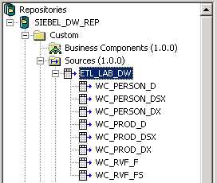
  - Change the database type to Oracle for all imported source objects.
    - Double-click WC_PERSON_D object.
    - Click the Table tab.
    - Click the Database type drop-down list box and change the database type from Microsoft SQL Server to Oracle.
    - Click Apply.
    - Click OK.
    - Repeat the above steps for all the below objects:
WC_PERSON_DSX
WC_PERSON_DX
WC_PROD_D
WC_PROD_DSX
WC_PROD_DX
WC_RVF_F
WC_RVF_FS
  - Select Repository > Save.
  - Verify that the tables were inserted.
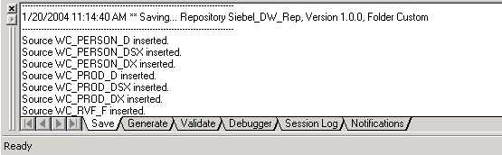
  - WC_PERSON_D table definition:
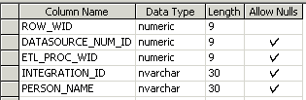
  - Preview WC_PERSON_D data:
    - Right-click the WC_PERSON_D table.
    - Select Preview Data.
    - Enter the following:
Username: | SIEBEL
Owner name: | dbo (Pre-selected)
Password: | SIEBEL
    - Click Connect.
    - Preview the WC_PERSON_D data.
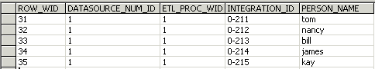
    - Click Close to close the Preview Data window.
  - WC_PROD_D table definition:
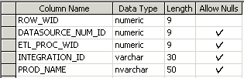
  - Preview WC_PROD_D data:
    - Right-click WC_PROD_D table.
    - Select Preview Data.
    - Enter the following:
Username: | SIEBEL
Owner name: | dbo (Pre-selected)
Password: | SIEBEL
    - Click Connect.
    - Preview the WC_PROD_D data.
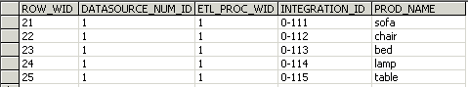
    - Click Close to close the Preview Data window.
- Import the ETL_LAB_DW target definition you will use to create a Source Dependent Extract (SDE) mapping.
  - Click the Custom folder and select Tools > Warehouse Designer.
  - Select Targets > Import from Database.
  - Select the ETL_LAB_DW (SQL Server) ODBC data source to connect to the target database.
  - Enter the following values:
Username: | SIEBEL
Owner name: | Enter SIEBEL if <ALL> is not pre-selected
Password: | SIEBEL
  - Click Connect.
  - Click All.
  - Expand dbo and the TABLES sub-folder.
  - Select the WC_RVF_F and WC_RVF_FS tables to import the definitions into the repository.
Note: You are downloading the WC_RVF_F table along with the WC_RVF_FS table. The WC_RVF_F table is used as the target in the mapping you are going to build in the next part of this lab.
  - Click OK.
  - In the Navigator, select Custom > Targets and verify that the WC_RVF_F and WC_RVF_FS tables appear.
  - Change the database type to Oracle for all imported target objects.
    - Double-click WC_RVF_F object.
    - Click the Table tab.
    - Click the Database type drop-down list box and change the database type from Microsoft SQL Server to Oracle.
    - Click Apply.
    - Click OK.
    - Repeat the above steps for WC_RVF_F object.
  - Select Repository > Save.
  - In the Output window, verify that the targets were inserted.
  - WC_RVF_F table definition:
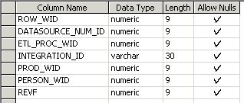
  - WC_RVF_FS table definition:
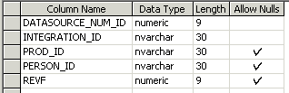
- Set ROW_WID as the primary key for WC_RVF_F.
  - Select Tools > Warehouse Designer.
  - In the Warehouse Designer window, double-click the WC_RVF_F table.
  - In the Edit Tables dialog box, click the Columns tab.
  - Select ROW_WID and select Primary Key as the Key Type.
  - Click Apply.
  - Click OK.
- Create the Source Dependent Extract mapping SDE_C_RevenueFact using the CustomTemplateSDE_AssetFact template provided in the Custom folder. Siebel Systems has provided this template for your convenience to aid development and customization efforts. It is easier to leverage an existing mapping and use its business logic and components including source and target definitions, transformations, mapplets, etc., than to build a new mapping from scratch. SDE_C_RevenueFact mapping extracts and moves the data from the source table S_REVN to the target fact staging table WC_RVF_FS. The data does not undergo any major transformations in this mapping as it is moved from the source to the target fact staging table. The C in the naming convention indicates that this is a custom mapping.
  - In the Custom folder, expand the Mappings sub-folder.
  - Select CustomTemplateSDE_AssetFact and drag it up to the Mappings folder to make a copy of it.
  - Click Yes to copy the mapping to the Custom folder.
  - In the Enter a New Mapping Name dialog box, type SDE_C_RevenueFact and click OK.
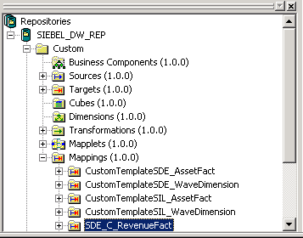
- Open the Mapping Designer and add the SDE_C_RevenueFact mapping.
  - Select Tools > Mapping Designer.
  - Drag and drop the SDE_C_RevenueFact mapping into the Mapping Designer window.
  - If prompted, click Yes to close the existing mapping. If desired, select Layout > Zoom Percent and modify the size of the mapping in the workspace.
- Add and modify the source definition for the SDE_C_RevenueFact mapping. Source definitions vary by mapping. In this lab, you are building a mapping to extract source data from the S_REVN table in the ETL_LAB_OLTP database.
  - Click LKP_DATASOURCE_NUM_ID and delete it. This Lookup transformation will not be used in this lab. In the real-world, this Lookup transformation is used to obtain DATASOURCE_NUM_ID value. For the purposes of this lab, we are going to code the DATASOURCE_NUM_ID to 1 and deleting this Lookup transformation.
  - Click Yes to confirm the delete.
  - Click S_ASSET Source Definition and SQ_S_ASSET Source Qualifier delete them.
  - Click Yes to confirm the delete.
  - From the ETL_LAB_OLTP source, drag and drop the S_REVN source into the Mapping Designer. By default, a Source Qualifier transformation is created.
- Link and modify the existing EXPTRANS Expression transformation. An Expression transformation is used to calculate values in a single row before writing to the target. In this step, you calculate the value of DATASOURCE_NUM_ID using a lookup procedure.
  - Drag and drop the ROW_ID column from SQ_S_REVN Source Qualifier to its corresponding column in EXPTRANS Expression Transformation.
  - Drag and drop PROD_ID, PERSON_ID, and REVF from SQ_S_REVN Source Qualifier to empty columns on EXPTRANS Expression transformation.
  - Delete the old port from EXPTRANS Expression.
    - Double-click EXPTRANS Expression.
    - Click the Ports tab of the Edit Transformations dialog box and select the OWNER_ACCNT_ID port. This port is not relevant for the custom mapping you are building.
    - Click the Delete button (with scissors) to delete the port. Do not delete any other ports.
  - Modify ports in EXPTRANS Expression.
    - Change the ROW_ID Port Name to INTEGRATION_ID.
    - For the DATASOURCE_NUM_ID port, click the down arrow button in the Expression column.
    - Change the formula to 1.
Note: DATASOURCE_NUM_ID is typically obtained as part of the SDE process using a reusable lookup procedure that always returns a value of 1 for Siebel transactional data. In a multi-source environment, you would need to decide appropriate values to use for DATASOURCE_NUM_ID to the SDE mapping using a lookup transformation. In this case, we are not using the lookup transformation procedure and hard coding it to 1 for simplicity.
    - Click OK.
    - Click OK to confirm that the expression parsed successfully.
    - Click Apply.
    - Click OK.
- Add and link the target definition. Target definitions vary by mapping. In this exercise, the target for data extracted from the S_REVN source is the WC_RVF_FS fact staging table in the ETL_LAB_DW database.
  - Click W_ASSET_FSX Target Definition and delete it.
  - Click Yes to confirm the deletion.
  - In the Navigator, expand the Targets sub-folder under Custom folder. Drag and drop WC_RVF_FS into the Mapping Designer window to create WC_RVF_FS Target Definition. Position WC_RVF_FS Target Definition such that it is right next to EXPTRANS Expression.
  - Drag and drop INTEGRATION_ID, DATASOURCE_NUM_ID, PROD_ID, PERSON_ID, and REVF from EXPTRANS Expression onto their corresponding columns in WC_RVF_FS Target Definition.
- Validate your work and update the repository.
  - View the mapping layout
    - Select Layout > Arrange.
    - Select WC_RVF_FS as the target and click OK.
    - Your mapping should like the below layout.
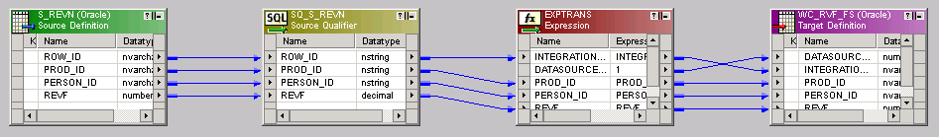
  - If necessary, select View > Output to view the Output window.
  - Click the Validate tab of the Output window and select Mappings > Validate to verify that there are no inconsistencies in the new mapping. You should get a message similar to the following:
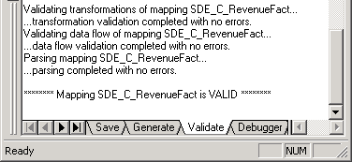
  - If your mapping is valid, select Repository > Save to update the repository.
- Leave Informatica Designer open for the next lab.
Lab 7-2 Creating an SIL Mapping for a Fact Table
Goals | To create a Source Independent Load (SIL) mapping that can be used to move data into the WC_RVF_F fact table from the WC_RVF_FS staging table and the WC_PERSON_D and WC_PROD_D dimension tables.
Scenario | You have built the SDE_C_RevenueFact extraction mapping necessary to stage the data for load into the fact staging table in Siebel Relationship Management Warehouse. You now must create the SIL mapping used to load the data into its ultimate destination in Siebel Relationship Management Warehouse.
Outcome | You will have a Source Independent Load (SIL) mapping that extracts the data from the W_RVF_FS, WC_PERSON_D, and WC_PROD_D tables and loads it into corresponding columns in WC_RVF_F on the Siebel Data Warehouse.
Time | 50 – 60 minutes
Instructions:
- If necessary, start the Informatica Designer tool and connect to the Siebel Informatica repository.
  - Select Start > Programs > Informatica PowerMart 6.2.1 Client > Designer.
  - Double-click Siebel_DW_Rep.
  - Enter the following in the Connect to Repository dialog box:
Username | Administrator
Password | Administrator
  - Click Connect.
- Create the Source Independent Load mapping SIL_C_RevenueFact using the CustomTemplateSIL_AssetFact template provided in the Custom folder. Again, it is easier to leverage an existing mapping and use its business logic and components including source and target definitions, transformations, mapplets, etc., than to build a new mapping from scratch. SIL_C_RevenueFact mapping is used to extract, transform and move the data from the fact staging table WC_RVF_FS to the target fact table WC_RVF_FS. The data undergoes significant changes in this mapping (through several transformations) as it is moved from the fact staging to the target table.
  - In the Custom folder, expand the Mappings sub-folder.
  - Select CustomTemplateSIL_AssetFact and drag it up to its parent Mappings folder to make a copy of it.
  - Click Yes to confirm the copy.
  - In the Enter a New Mapping Name dialog box, type SIL_C_RevenueFact and click OK.
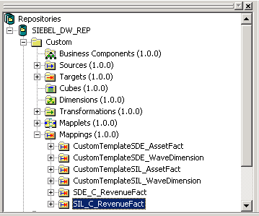
- Open the Mapping Designer to begin modifying the SIL_C_RevenueFact mapping.
  - Select Tools > Mapping Designer.
  - Drag and drop the SIL_C_RevenueFact mapping into the Mapping Designer window.
  - If prompted, click Yes to close the existing mapping.
- Add a lookup transformation to look up MAX_ROW_WID on the WC_REV_F table. This will be an unconnected lookup transformation and the value from this transformation will be used later by an expression transformation (EXP_NEXTVAL_WITH_INSERT_UPDATE_FLAG) to generate unique ROW_WIDs for inserted records and to retain existing ROW_WIDs for updated records.
  - Select Transformation > Create.
  - In the Create Transformation dialog box, enter the following:
Transformation type | Lookup
Name | LKP_WC_RVF_F_MAX_ROW_WID
  - Click Create.
  - In the Select Lookup Table for Lookup Transformation dialog box, select WC_RVF_F from the list and click OK.
Note: The lookup table for this transformation is the target table WC_RVF_F and not the staging table.
  - Click Done to close the Create Transformation dialog box.
  - Double-click the LKP_WC_RVF_F_MAX_ROW_WID lookup transformation to open the Edit Transformations dialog box.
  - Click the Ports tab and edit the ports.
    - Designate the ROW_WID port as the return port by checking the R attribute for it. This is the column of data that will be returned based on the lookup condition.
    - Deselect the Output (O) port for all ports, with the exception of ROW_WID.
    - Create a new transformation port for the Maximum ROW_WID lookup value.
      - Click the Add a New Port button (to the left of the scissors).
      - Give the new port the following attributes:
Name | MAX_ROW_WID_LKP_VAL
Datatype | Decimal
Prec | 18
Port Type | Input (Select the ‘I’ check box)
  - Click Apply. Ignore the warning and click Yes to continue.
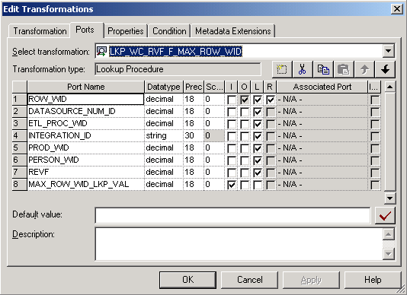
  - Click the Properties tab and enter the SQL to lookup the Max ROW_WID from the WC_RVF_F table.
    - For the Lookup SQL Override transformation attribute, click the down arrow button in the Value field to open the SQL Editor.
    - Enter the SQL to appear as follows. Examine the SQL carefully. It is always going to retrieve the max ROW_WID value from WC_RVF_F regardless of the input.
SELECT
MAX(ROW_WID) as ROW_WID
FROM WC_RVF_F
    - To validate the SQL, enter the following:
ODBC data source | ETL_LAB_DW (SQL Server)
Username: | SIEBEL
Password: | SIEBEL
    - Click Validate.
    - You should receive a message indicating that no errors were detected.
    - Click OK.
    - Click OK in the SQL Editor.
  - Click the Condition tab and enter a lookup condition. Note that the intended functionality of this transformation, which is intended to simply look up the MAX_ROW_WID of the target table, is performed by the SQL Override you created above. Informatica requires that Lookup transformations contain one or more lookup conditions. To meet this requirement, you will now create a lookup condition that filters out any rows with the value ROW_WID = -1. Because this case never occurs, this lookup condition can best be described as a non-functional mask used to meet the Informatica requirement for Lookup transformations. You will pass the value of -1 when you call the LKP_WC_RVF_MAX_ROW_WID lookup from EXP_FLAG transformation later in the lab.
    - Click the Add a New Condition button (to the left of the scissors).
    - Enter the following attributes in the condition. This condition filters out invalid values.
Lookup Table Column | ROW_WID
Operator | !=
Transformation Port | MAX_ROW_WID_LKP_VAL
  - Click Apply.
  - Click OK to close the Edit Transformations dialog box.
- Delete the LKP_ETL_PROC_WID lookup procedure.
  - Select the LKP_ETL_PROC_WID lookup procedure and delete it.
  - Click Yes to confirm the deletion.
- Add and modify source definitions for the mapping.
  - Select W_ASSET_FSX and W_ORG_D source definitions and delete them.
  - Click Yes to confirm the deletions.
  - In the Navigator, select Custom > Sources > ETL_LAB_DW and expand ETL_LAB_DW.
  - Drag and drop the WC_PERSON_D, WC_PROD_D, and WC_RVF_FS sources into the Mapping Designer window. By default, a new Source Qualifier transformation is created for each new Source Definition.
  - Delete the new Source Qualifier transformations for each new source definition. This includes SQ_WC_PERSON_D Source Qualifier, SQ_WC_PROD_D Source Qualifier, and SQ_WC_RVF_FS Source Qualifier. You will be reusing the existing Source Qualifier transformation in this mapping.
  - Click Yes to confirm the deletions.
- Rename, modify, and link the existing Source Qualifier transformation. This transformation joins rows from the staging table (WC_RVF_FS) with the dimension tables (WC_PERSON_D, WC_PROD_D) to retrieve the dimension keys by joining on the INTEGRATION_ID and DATASOURCE_NUM_ID (See SQL statement in this transformation). The Source Qualifier transformation represents the row set retrieved from source objects before undergoing subsequent transformations.
  - Double-click SQ_W_ASSET_FSX Source Qualifier.
  - In the Transformation tab of the Edit Transformations dialog box, click Rename.
  - In the Rename Transformation dialog box, type SQ_JOINER_RevenueFact and click OK.
  - Click Apply.
  - Click OK.
  - Drag ROW_WID from WC_PERSON_D Source Definition to a blank column on SQ_JOINER_RevenueFact Source Qualifier.
  - Rename the new ROW_WID column in the SQ_JOINER_RevenueFact Source Qualifier.
    - Double-click SQ_JOINER_RevenueFact Source Qualifier.
    - Click the Ports tab.
    - Select the ROW_WID port and change the name to PERSON_WID.
    - Click OK.
  - Drag ROW_WID from WC_PROD_D Source Definition to a blank column on SQ_JOINER_RevenueFact Source Qualifier.
  - Rename the new ROW_WID port in the SQ_JOINER_RevenueFact Source Qualifier.
    - Double-click SQ_JOINER_RevenueFact Source Qualifier.
    - Click the Ports tab.
    - Select the ROW_WID port and change the name to PROD_WID.
    - Click OK.
  - Drag and drop INTEGRATION_ID from WC_RVF_FS Source Definition to its corresponding column on SQ_JOINER_RevenueFact Source Qualifier.
  - Drag and drop DATASOURCE_NUM_ID from the WC_RVF_FS Source Definition to its corresponding column on SQ_JOINER_RevenueFact Source Qualifier.
  - Drag and drop REVF from WC_RVF_FS Source Definition to a blank column on SQ_JOINER_RevenueFact Source Qualifier.
  - Delete the old port from the SQ_JOINER_RevenueFact Source Qualifier transformation.
    - Double-click SQ_JOINER_RevenueFact Source Qualifier.
    - Click the Ports tab in the Edit Transformations dialog box.
    - Select the ACCNT_ROW_WID port.
    - Click the Delete button (with scissors) to delete the port. Do not close the Edit Transformations dialog box.
  - Edit the SQ_JOINER_RevenueFact Source Qualifier transformation’s SQL query to reference the correct tables and columns. You are going to use the SQL Override option to customize the default query.
    - In the Edit Transformations dialog box, click the Properties tab.
    - For the Sql Query Transformation Attribute, click the down arrow button in the Value field to open the SQL Editor.
    - Edit the SQL to appear as follows. Examine the SQL carefully. It joins the fact staging table (WC_RVF_FS) to the dimension tables to retrieve the following ROW_WIDs: PROD_WID from WC_PROD_D and PERSON_WID from WC_PERSON_D.

SELECT
WC_RVF_FS.INTEGRATION_ID,
WC_RVF_FS.DATASOURCE_NUM_ID,
WC_PERSON_D.ROW_WID,
WC_PROD_D.ROW_WID,
WC_RVF_FS.REVF
FROM
WC_PERSON_D,
WC_PROD_D,
WC_RVF_FS
WHERE
WC_RVF_FS.PERSON_ID=WC_PERSON_D.INTEGRATION_ID AND
WC_RVF_FS.DATASOURCE_NUM_ID=WC_PERSON_D.DATASOURCE_NUM_ID
AND
WC_RVF_FS.PROD_ID=WC_PROD_D.INTEGRATION_ID AND
WC_RVF_FS.DATASOURCE_NUM_ID=WC_PROD_D.DATASOURCE_NUM_ID
    - To validate the SQL, enter the following:
ODBC data source | ETL_LAB_DW (SQL Server)
Username: | SIEBEL
Password: | SIEBEL
    - Click Validate.
You should receive a message indicating that “Query should return exactly 2 field(s) to match field(s) project from the Source Qualifier.” Because this mapping is not validated yet, it is okay to get this message.
    - Click OK.
    - Click OK in the SQL Editor.
    - The order of columns in the SELECT statement should match the order of the ports in this mapping. If necessary, click the Ports tab and use the up and down arrows to adjust the order of the ports.
    - Click Apply and then OK in the Edit Transformations dialog box.
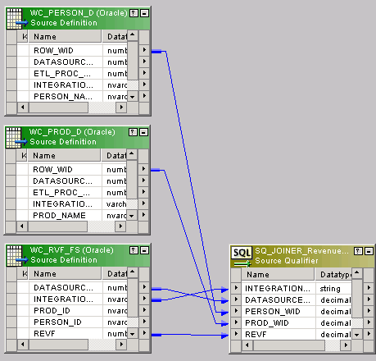
- Create a new expression transformation object. This transformation uses a lookup transformation to retrieve the value of ETL process id ETL_PROC_WID.
  - Select Transformation > Create.
  - In the Create Transformation dialog box, enter the following:
Transformation type | Expression
Name | EXP_ETL_PROC_WID
  - Click Create.
  - Click Done.
  - Move EXP_ETL_PROC_WID Expression such that it appears to the right of SQ_JOINER_RevenueFact Source Qualifer transformation you create above.
  - Drag and drop INTEGRATION_ID and DATASOURCE_NUM_ID ports from SQ_JOINER_RevenueFact source qualifier to empty columns on EXP_ETL_PROC_WID Expression transformation object. These ports will be used in the lookup transformation in the next step.
  - Add a new port in EXP_ETL_PROC_WID Expression.
    - Double-click EXP_ETL_PROC_WID Expression.
    - Click the Ports tab and click Add a New Port button.
    - Give the new port the following attributes:
Name | ETL_PROC_WID
Datatype | Decimal
Prec | 10
Port Type | Output
    - For the ETL_PROC_WID port, click the down arrow button in the Expression column.
    - Change the formula to 1. Typically, in an SIL mapping, the ETL_PROC_WID would be retrieved using LKP_ETL_PROC_WID reusable lookup procedure. In this lab, we are going to code the ETL_PROC_WID to 1 for simplicity.
    - Click OK.
    - Click OK to confirm expression parsed successfully.
    - Click Apply to save the changes.
    - Click OK to close the Edit Transformation window.
- Rename, modify, and link the existing LKP_W_ASSET_F Lookup Procedure. This transformation queries the target table to determine which rows have the same INTEGRATION_ID and DATASOURCE_NUM_ID. These rows will be updated, while the rest of the rows in the staging table will be inserted in the target table. The lookup also passes the ETL_PROC_WID for use in a later filter.
  - Double-click LKP_W_ASSET_F Lookup Procedure.
  - In the Transformation tab of the Edit Transformations dialog box, click Rename.
  - In the Rename Transformation dialog box, type LKP_WC_RVF_F and click OK.
  - In the Description field, type Returns the ROW_WID and ETL_PROC_WID of WC_RVF_F.
  - Click Apply to apply the changes.
  - Edit the ports.
    - Delete the old ports from this lookup procedure.
      - Click the Ports tab of the Edit Transformation dialog box and select IN_INTEGRATION_ID and IN_DATASOURCE_NUM_ID ports. To select multiple ports, you can move the mouse over the number and press Shift+Click to select the ports one at a time.
      - Click the Delete button (with scissors) to delete the port. Ignore the warning and click Yes to continue. Do not close the dialog box.
    - Create a new lookup port for the ETL_PROC_WID lookup value. This will be output to a later filter transformation, which ensures that rows with matching ETL Process IDs are not inserted.
      - Click the Add a New Port button (to the left of the scissors).
      - Give the new port the following attributes:
Name | ETL_PROC_WID
Datatype | Decimal
Prec | 10
Port Types | Lookup (L) and Output (O)
    - Click Apply to apply the changes. Ignore the warning and click Yes to continue.
    - Click OK to close the Edit Transformation window.
  - Drag and drop INTEGRATION_ID and DATASOURCE_NUM_ID ports from EXP_ETL_PROC_WID Expression transformation to empty columns in LKP_WC_RVF_F lookup transformation.
  - Double-click LKP_WC_RVF_F Lookup Procedure.
  - Modify ports in LKP_WC_RVF_F Lookup Procedure.
    - Change the INTEGRATION_ID1 Port Name to IN_INTEGRATION_ID.
    - Change the DATASOURCE_NUM_ID1 Port Name to IN_DATASOURCE_NUM_ID.
  - Rearrange the ports to look like the following. You can use the Move Up and Move Down buttons to move up or down a port.
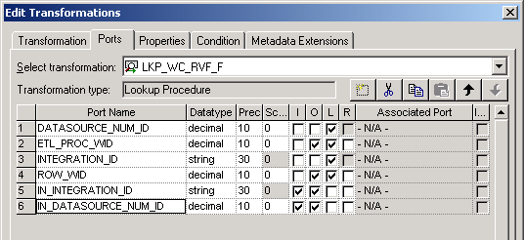
  - Click the Properties tab.
  - For the Lookup table name transformation attribute, change the value to WC_RVF_F.
  - For the Lookup Sql Override transformation attribute, click the down arrow button in the Value field to open the SQL Editor.
Enter the following SQL. Examine the Loop SQL Override carefully. It retrieves all rows from the fact table (WC_RVF_F) for which there are matching rows in the fact staging table (WC_RVF_FS). These matching rows will be updated in the fact table (WC_RVF_F) through subsequent transformations.
SELECT
WC_RVF_F.ETL_PROC_WID as ETL_PROC_WID,
WC_RVF_F.ROW_WID as ROW_WID,
WC_RVF_F.INTEGRATION_ID as INTEGRATION_ID,
WC_RVF_F.DATASOURCE_NUM_ID as DATASOURCE_NUM_ID
FROM
WC_RVF_FS,
WC_RVF_F
WHERE
WC_RVF_FS.INTEGRATION_ID=WC_RVF_F.INTEGRATION_ID
AND
WC_RVF_FS.DATASOURCE_NUM_ID=WC_RVF_F.DATASOURCE_NUM_ID
  - To validate the SQL, enter the following:
ODBC data source: | ETL_LAB_DW (SQL Server)
Username: | SIEBEL
Password: | SIEBEL
  - Click Validate.
  - Click OK to confirm that no errors were detected.
  - Click OK to close the SQL Editor.
  - Click the Condition tab to verify that the lookup condition is valid. It should compare the INTEGRATION_ID and DATASOURCE_NUM_ID lookup table columns with the IN_INTEGRATION_ID and IN_DATASOURCE_NUM_ID transformation ports. For records meeting the lookup condition, the ROW_WID and ETL_PROC_WID will be output.
    - Click the Add a New Condition button for INTEGRATION_ID and enter the following attributes:
Lookup Table Column | INTEGRATION_ID
Operator | =
Transformation Port | IN_INTEGRATION_ID
    - Click the Add a New Condition button for DATASOURCE_NUM_ID with the following attributes:
Lookup Table Column | DATASOURCE_NUM_ID
Operator | =
Transformation Port | IN_DATASOURCE_NUM_ID
  - Click Apply.
  - Click OK.
- Delete the LKP_W_ASSET_FX lookup procedure. The lookup on the fact extension table, LKP_W_ASSET_FX, will not be used for the purposes of this lab.
  - Select the LKP_W_ASSET_FX lookup procedure and delete it.
  - Click Yes to confirm the deletion.
- Delete the EXPTRANS Expression transformation. This transformation will not be used for the purposes of this lab.
  - Select the EXPTRANS Expression transformation and delete it.
  - Click Yes to confirm the deletion.
- Modify and link the FILTRANS Filter transformation. This transformation filters out rows that have already been inserted or updated when a session is restarted. FIL_ETL_PROC_WID filters out rows that have the same DATASOURCE_NUM_ID and ETL_PROC_WID in the target table.
  - Double-click FILTRANS Filter transformation
  - In the Transformation tab of the Edit Transformations dialog box, click Rename.
  - In the Rename Transformation dialog box, type FIL_ETL_PROC_WID and click OK.
  - In the Description field, type Filters out rows that have already been inserted/updated when a session is restarted.
  - Click Apply.
  - Delete all ports
    - Click the Ports tab.
    - Delete all ports by selecting each port and clicking the scissors symbol.
    - Click Apply.
  - Click OK.
  - Drag and drop Ports INTEGRATION_ID , DATASOURCE_NUM_ID, ETL_PROC_WID from EXP_ETL_PROC_WID Expression transformation on empty columns on FIL_ETL_PROC_WID Filter transformation.
  - Drag and drop Ports ETL_PROC_WID and ROW_WID from LKP_WC_RVF_F transformation on empty columns on FIL_ETL_PROC_WID Filter transformation.
  - Drag and drop Ports PERSON_WID, PROD_WID and REVF from SQ_JOINER_RevenueFact Source Qualifier on empty columns on FIL_ETL_PROC_WID Filter transformation.
  - Modify ports for FIL_ETL_PROC_WID Filter.
    - Double-click FIL_ETL_PROC_WID Filter.
    - Click the Ports tab.
    - Rename the following ports sourced from LKP_WC_RVF_F Lookup Procedure. The names of ports sourced from EXP_ETL_PROC_WID Expression transformation are not changed.
ETL_PROC_WID1 to LKP_ETL_PROC_WID
ROW_WID to LKP_ROW_WID

    - Rearrange the ports to look like the below. You can use Move Up and Move Down arrow buttons to rearrange the order.
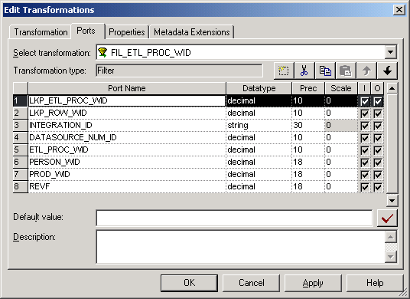
  - Modify properties for FIL_ETL_PROC_WID Filter.
    - Click the Properties tab.
    - For the Filter Condition transformation attribute, click the down arrow button in the Value field to open the Expression Editor.
    - Enter the below Formula. This SQL only allows records that are not already inserted or updated in the current ETL session or records whose existing ETL_PROC_WIDs are null.
ISNULL(LKP_ETL_PROC_WID) OR (ETL_PROC_WID!=LKP_ETL_PROC_WID)
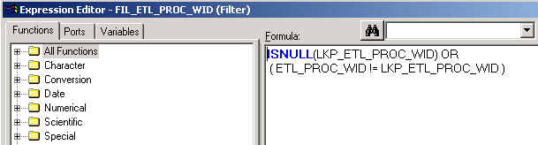
    - Click Validate.
    - Click OK to confirm that the expression parsed successfully.
    - Click OK to close Expression Editor.
    - Click Apply.
    - Click OK.
- Create, modify and link a new Expression Transformation. This transformation is used to accomplish the following: 1) to create a flag to identify whether a row is a new or existing row, 2) to assign the value of Unspecified when PERSON_WID or PROD_WID does not contain valid value, and 3) to calculate the MAX_ROW_WID value using the LKP_WC_RVF_MAX_ROW_WID.
  - In the Informatica PowerMart Designer menu bar, select Transformation > Create.
  - In the Create Transformation dialog box, select Expression from the drop-down list.
  - Type EXP_FLAG as the Expression name.
  - Click Create.
  - Click Done.
  - Move EXP_FLAG Expression such that it appears to the right of FIL_ETL_PROC_WID Filter transformation.
  - Drag and drop all ports except LKP_ETL_PROC_WID from FIL_ETL_PROC_WID Filter transformation to EXP_FLAG Expression Transformation.
  - Double-click EXP_FLAG Expression.
  - Rename and edit the ports to make them Input Ports.
    - Click the Ports tab.
    - Rename the Port PERSON_WID to IN_PERSON_WID and PROD_WID to IN_PROD_WID.
    - Deselect Output (O) for both IN_PROD_WID and IN_PERSON_WID.
    - Click Apply.
  - Add a variable port to hold a value for rows whose PROD_WID or PERSON_WID is unspecified. Every dimension table in the Siebel Relationship Management Warehouse has an unspecified record with the ROW_WID value of “0”. For records whose PROD_WID or PERSON_WID values are unspecified, they will be hard-coded with this unspecified value to avoid populating null values.
    - Click the Add a new port to this transformation button.
    - Type ETL_UNSPEC_NUM as the Port Name.
    - Set the Port Type as variable (V).
    - Set the Datatype to decimal.
    - For the ETL_UNSPEC_NUM port, click the down arrow button in the Expression field to open the Expression Editor.
    - Type 0 as the formula.
    - Click Validate.
    - Click OK to confirm expression parsed successfully.
    - Click OK to close the Expression Editor.
    - Click Apply.
  - Add an output port to output a PROD_WID that substitutes the unspecified value if there is no input value from the source qualifier. For records whose PROD_WID values are unspecified, this will set the PROD_WID column value to refer the unspecified record in the dimension table (WC_PROD_D).
    - Click the Add a new port to this transformation button.
    - Type PROD_WID as the Port Name.
    - For the PROD_WID port, deselect input (I).
    - Set the Datatype to decimal and the Prec to 18.
    - For the PROD_WID port, click the down arrow button in the Expression field to open the Expression Editor.
    - Delete the existing formula and enter the formula to substitute the unspecified value.
      - Delete the existing Formula.
      - Expand the All Functions folder to build the Formula.
      - Double-click the IIF function to add it to the Formula.
Note: The IIF function in Informatica returns one of two values you specify based on the results of a condition. For example, the syntax IIF(condition, value1, value2) returns value1 if the condition is evaluated to TRUE or else value2 if the condition is evaluated to FALSE.
      - Click in the IIF function’s parentheses in the Formula window.
      - Double-click the ISNULL function to nest it in the IFF function.
Note: The ISNULL function returns the value of ‘1’ if evaluated to TRUE or ‘0’ if evaluated to FALSE.
      - Click in the ISNULL function’s parentheses in the Formula window.
      - In the Ports tab, expand the EXP_FLAG transformation and double-click the IN_PROD_WID port to add it to the formula.
      - Click between the close parentheses of the IIF and ISNULL functions and click the Operator keypad’s comma button to insert a comma.
      - In the Ports tab, double-click the ETL_UNSPEC_NUM port to add it to the formula. The “0” value will be taken if the IN_PROD_WID is null.
      - Add a comma.
      - In the Ports tab, double-click the IN_PROD_WID port. If there is a value it will be used.
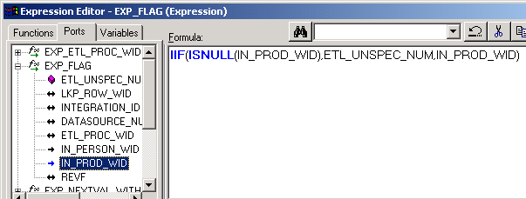
    - Click Validate.
    - Click OK to confirm that the expression parsed successfully.
    - Click OK to close the Expression Editor.
    - Click Apply and leave the Edit Transformations dialog box open.
  - Add an output port to output a PERSON_WID that substitutes the unspecified value if there is no input value from the source qualifier. For records whose PERSON_WID values are unspecified, this will set the PERSON_WID column value to refer the unspecified record in the dimension table (WC_PERSON_D). The steps to configure PERSON_WID port are in the same order you followed to configure PROD_WID port.
    - Click the Add a new port to this transformation button.
    - Type PERSON_WID as the Port Name.
    - For the PERSON_WID port, deselect input (I).
    - Set the Datatype to decimal and the Prec to 18.
    - Click the down arrow button in the Expression field to open the Expression Editor.
    - Delete the existing formula and enter the formula to substitute the unspecified value.
      - Expand the All Functions folder to build the Formula.
      - Double-click the IIF function to add it to the Formula.
      - Click in the IIF function’s parentheses in the Formula window.
      - Double-click the IsNull function to nest it in the IFF function.
      - Click in the ISNULL function’s parentheses in the Formula window.
      - In the Ports tab, expand the EXP_FLAG transformation and double-click the IN_PERSON_WID port to add it to the formula.
      - Click between the close parentheses of the IIF and ISNULL functions and click the Operator keypad’s comma button to insert a comma.
      - In the Ports tab, double-click the ETL_UNSPEC_NUM port to add it to the formula. The “0” value will be taken if the IN_PERSON_WID is null.
      - Add a comma.
      - In the Ports tab, double-click the IN_PERSON_WID port. If there is a value it will be used.
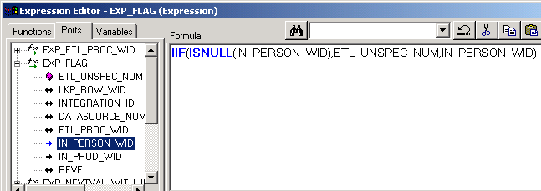
    - Click Validate.
    - Click OK to confirm that the expression parsed successfully.
    - Click OK to close the Expression Editor.
    - Click Apply and leave the Edit Transformations dialog box open.
  - Add an output port to bring in the MAX_ROW_WID from the lookup transformation you created above.
    - Click the Add a new port to this transformation button (to the left of the scissors).
    - Type MAX_ROW_WID as the Port Name.
    - For the MAX_ROW_WID, deselect input (I).
    - Set the Datatype to decimal and the Prec to 18.
    - For the MAX_ROW_WID port, click the down arrow button in the Expression field to open the Expression Editor.
    - Delete the existing formula and in the Functions tab, expand Lookups and double-click the LKP_WC_RVF_MAX_ROW_WID lookup to add it to the Formula. In the lookup’s parentheses, type -1.
Note: Recall that, above, you set up the LKP_WC_RVF_F_MAX_ROW_WID lookup transformation to filter out rows with a ROW_WID value of -1. In this formula, you are calling the lookup and passing a value of -1 to nullify that condition. Also recall that the MAX_ROW_WID is determined by the SQL Override in the Lookup transformation. So in effect, this condition filters out invalid values and retrieves the MAX ROW_WID value from the WC_RVF_F table.
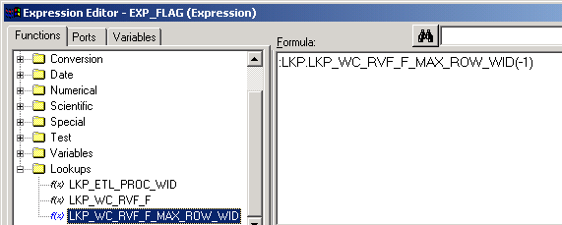
    - Click Validate.
    - Click OK to confirm expression parsed successfully.
    - Click OK to close the Expression Editor.
    - Click Apply.
  - Add an output port to output an Insert/Update flag based on the ROW_WID value.
    - Click the Add a new port to this transformation button.
    - Type INSERT_UPDATE_FLAG as the Port Name.
    - For the INSERT_UPDATE_FLAG port, deselect input (I).
    - Click the down arrow button in the Expression field to open the Expression Editor.
    - Delete the existing formula and enter the formula to set an Insert/Update flag. If the ROW_WID is null, the record should be marked for insert. If it is not null, the record should be marked for update.
      - Expand the All Functions folder to build the Formula.
      - Double-click the IIF function to add it to the Formula.
      - Click in the IIF function’s parentheses in the Formula window.
      - Double-click the IsNull function to nest it in the IFF function.
      - Click in the ISNULL function’s parentheses in the Formula window.
      - In the Ports tab, expand the EXP_FLAG transformation and double-click the LKP_ROW_WID port to add it to the Formula.
      - Manually edit the formula to set the flag. It should appear as follows. It sets the condition for determining whether a record should be inserted or updated based on the lookup ROW_WID value.
IIF(ISNULL(LKP_ROW_WID),
'INSERT',
'UPDATE'
)
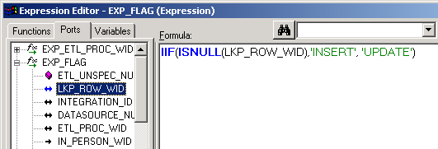
    - Click Validate.
    - Click OK to confirm that the expression parsed successfully.
    - Click OK to close the Expression Editor.
  - Rearrange the Ports on EXP_FLAG transformation to look like the below.
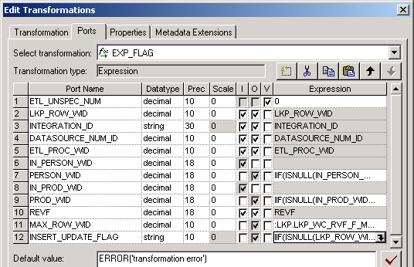
  - Click Apply and OK to close the Edit Transformations window.
  - Leave the SIL_C_RevenueFact mapping open.
- Copy the reusable EXP_NEXTVAL_WITH_INSERT_UPDATE_FLAG transformation from the SIL folder to the Custom folder. This reusable Expression transformation is used to generate unique ROW_WID value for new records and to maintain existing ROW_WID values for updated records using MAX_ROW_WID and INSERT_UPDATE_FLAG as inputs.
  - Expand the SIL folder.
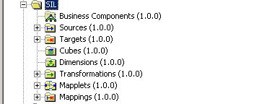
  - Expand the Transformations sub-folder.
  - Locate and click the EXP_NEXTVAL_WITH_INSERT_UPDATE_FLAG reusable transformation.
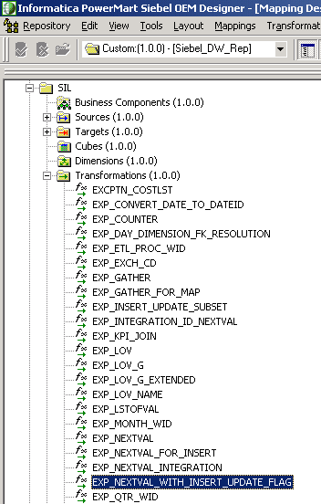
  - Select Edit > Copy.
  - Click the Transformations sub-folder in the Custom folder.
  - Select Edit > Paste.
  - Click Yes to copy the transformation to the Custom folder.
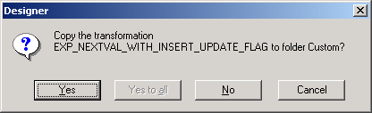
  - Click Yes to copy the transformation to the Custom folder.
  - In the Custom folder, expand the Transformation sub-folder
  - Drag the EXP_NEXTVAL_WITH_INSERT_UPDATE_FLAG Expression Transformation to SIL_C_RevenueFact mapping. Position this Expression Transformation right next to EXP_FLAG Expression transformation.
  - Drag and drop the following ports from EXP_FLAG Expression transformation to appropriate ports on EXP_NEXTVAL_WITH_INSERT_UPDATE_FLAG Expression transformation:
EXP_FLAG Expression (Source) | EXP_NEXTVAL_WITH_INSERT_UPDATE_FLAG Expression (Target)
MAX_ROW_WID | MAX_ROW_WID_IN
LKP_ROW_WID | ROW_WID_IN
INSERT_UPDATE_FLAG | INSERT_UPDATE_FLAG
- Rename, modify, and link the UPDTRANS Update Strategy. This reusable Update Strategy transformation is used to handle the update strategy for rows for insert and updates.
  - Double-click the UPDTRANS Update Strategy.
  - Rename to UPD_INSERT_UPDATE_WC_RVF_F.
  - Click OK.
  - Delete all Ports
    - Click Ports tab
    - Select Port ASSET_F_ROW_WID and click the Delete a port button
    - Repeat the above step for all Ports
  - Click Apply and OK to close the Edit Transformations window
  - Drag and drop INSERT_UPDATE_FLAG and NEXTVAL ports from EXP_NEXTVAL_WITH_INSERT_UPDATE_FLAG Expression transformation on empty columns in UPD_INSERT_UPDATE_WC_RVF_F Update Strategy transformation
  - Drag and drop the following columns from EXP_FLAG Expression transformation to empty columns on UPD_INSERT_UPDATE_WC_RVF_F:
INTEGRATION_ID
DATASOURCE_NUM_ID
ETL_PROC_WID
PERSON_WID
PROD_WID
REVF
  - Modify the ports for UPD_INSERT_UPDATE_WC_RVF_F.
    - Double-click UPD_INSERT_UPDATE_WC_RVF_F.
    - Click the Properties tab.
    - For the Update Strategy Expression transformation attribute, click the down arrow button in Value field to open the Expression Editor.
    - Enter the following formula. The Update Strategy transformation uses this logic to decide whether a given record should be inserted or updated based on the value of INSERT_UPDATE_FLAG port set in the previous step.
IIF((INSERT_UPDATE_FLAG = 'INSERT'),DD_INSERT,DD_UPDATE)
    - Click Validate to validate the Update Strategy Expression:
    - Click OK to confirm that the expression parsed successfully.
    - Click OK to close the Expression Editor.
    - Click Apply and OK.
- Add and link the target definition. You are including the target fact table (WC_RVF_F) to this mapping.
  - Delete W_ASSET_FX Target Definition.
  - Click Yes to confirm the deletion.
  - In the Navigator, select Custom > Targets and drag WC_RVF_F into the Mapping Designer.
  - Link the following columns from UPD_INSERT_UPDATE_WC_RVF_F to their corresponding columns on WC_RVF_F:
INTEGRATION_ID
DATASOURCE_NUM_ID
ETL_PROC_WID
PROD_WID
PERSON_WID
REVF
  - Link NEXTVAL from UPD_INSERT_UPDATE_WC_RVF_F to ROW_WID in WC_RVF_F.
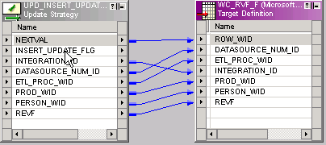
- Validate your work and update the repository.
  - View the mapping layout.
    - Select Layout > Arrange.
    - Select WC_RVF_F as the target and Iconic check box.
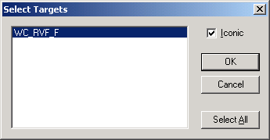
    - Click OK.
    - Your mapping should like the below layout.
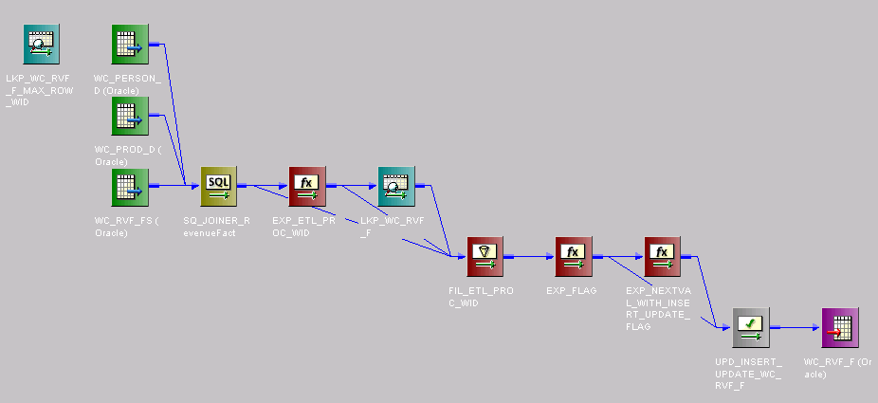
  - If necessary, select View > Output to view the Output window.
  - Click the Validate tab of the Output window and select Mappings > Validate to verify that there are no inconsistencies in the new mapping. You should get a message similar to the following:
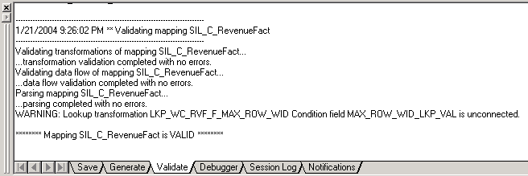
  - If your mapping is valid, select Repository > Save to update the repository.

